Why Discussions?
We'll have discussions in about 10 of our 16 lessons. Some will be writing based, some video based, some both. We'll provide how-to videos and instructions. Some weeks we won't have discussions because instead we'll be holding peer review or working on finalizing projects. Even so, these discussions are important because they'll allow you to integrate what you're learning, to experiment with style, and to build a community.

One major reason for why we've featured discussions so centrally in our course is because we know they can be effective. Writing Together, co-authored by an expert online writing instructor, Dr. Scott Warnock, and his student, Diana Gasiweski, provides strong evidence that, contrary to common beliefs, online writing class discussions can be rich and rewarding. Check out the press release for the book here.
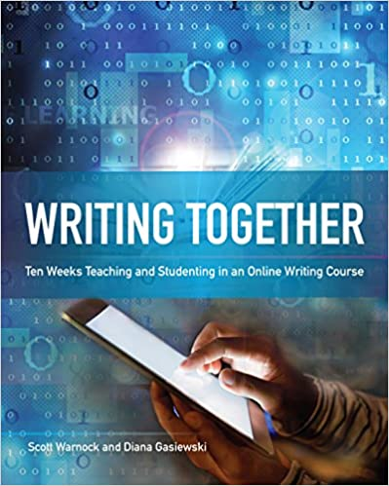

How Will Discussions Be Graded?
You'll create posts based on expected word counts or video lengths, but so much of what makes for quality discussions cannot be counted. Quality discussions online—and in real life—take time and listening. We know this. You know this. We also believe the opportunities of online discussions outweigh the inherent challenges.
In this class, we're expecting a semi-formal writing style. That means that discussions are places where you can experiment with the skills you're learning in the course. Your posts shouldn’t be perfected, but well-constructed; they shouldn’t be transactional, but mindful. Work this semester on developing your own style—one that optimizes your clarity, cogency, and charity, one that maximizes your power. Here’s our rubric:
- Full credit: Responses show original thinking, are written clearly and compellingly, demonstrate the student has read, understood, and integrated concepts from Mindful Writing and other class materials, cite specifics from the reading(s) in MLA style, and reflect a voice, a writer thinking and engaging. Word count/video lengths are met, but the quality of the responses goes beyond simply reaching a quota. And guess what? You can reach this level even if you make some mistakes or have some typos—perfection not required. The responses thus create an ethos of honesty and humanity, revealing someone we can trust.

- Partial credit (high): Responses are written clearly, show sound (though not necessarily perceptive or original) thinking, use key terms from class materials, and answer the question thoroughly, with clear but not necessarily well-constructed writing, numerous mistakes and typos distracting readers. Word count/video lengths are met. We expect the average response to be at this level, but know anyone can reach the next level with added effort.

- Partial credit (low): Responses reflect quick, cursory, or sloppy writing or don’t respond to the question or show overly simplistic, surface, or cliché thinking, or merely regurgitate the reading. Word count/video lengths are not met, or the posts are late. Responses feel like they’re simply attempts to check off a box.

- No credit: no responses.

How Should I Prepare for Discussions?
We've designed the lessons so that you'll read, watch videos, and complete some assignments early in the lesson and then engage in discussions toward the end. Because we want these discussions to be dynamic, you should read as many of the posts as possible. Treat this reading time as if it were class time for an in-person course, where you come to listen to and learn from your peers and instructor. Your instructor will also post weekly, sometimes responding to you individually, sometimes responding to the class. Your instructor may award extra credit to students who post early and often; conversely, instructors may deduct points for poor participation.
Regardless of the specifics of a lesson, this pattern holds for all discussions: you'll respond to the prompt (part 1) on Wednesdays, worth 5 points, and you'll post your responses to your peers (part 2) between Wednesdays and Saturdays, worth 5 points. One reason for this division is to give you clear to-do list items for easy reference.
You'll be assigned at some time to be a discussion moderator or co-moderator. That likely means you'll be the first to post, you'll check in daily, and you'll post extra. Your instructor will contact you soon about your turn! As another heads up, we'll use these hashtags to orient you about the types of posts that are most helpful in future discussions: #create #connect #analyze #understand #apply #evaluate. They'll be explained when they're required.

