Emotion (Pathos):
“The emotions are those things through which, by undergoing change, people come to differ in their judgments” (Aristotle).
Strategies to Establish Pathos:
STRATEGY: | DEFINITION: | EXAMPLE:
Give Concrete Details: | “Vivid examples have more persuasive power than a barrage of statistics . . . Tangible, concrete language creates images in the mind, which in turn act on our emotional imagination” (Jackson 126). | For one group, the request letter gave statistics for the sad state of children in Africa . . . However, another group’s request letter introduced them to Rokia, a ‘desperately poor; seven-year-old girl from Mali, facing ‘the threat of severe hunger or even starvation.’ Participants who learned about Rokia contributed twice as much (126).
Tell Stories: | We’re wired for stories and can use them rhetorically. | Slum Lords personal story.
Tap Shared Values: | One way to evoke emotion in your audience is to express support for something valued by the discourse community in which you and your readers belong. | We should use paper towels sparingly because they come from natural resources—and we should preserve our natural resources.
Amplify Word Choice: | Think about how different words create different responses. | Think of cheap vs. inexpensive
Call Your Audience to Action: | Somewhere in your writing, you’ll want to tell readers why what you’ve written matters. Tell them what they should change in their attitude or actions.

Emotion/Pathos Fallacies:
DO NOT DO THESE:
FALLACY: | DEFINITION: | EXAMPLE:
Ad populum/bandwagon appeal: | popular appeal or judgment; do/think something because other people are
Threats/rewards: | - diverts attention to neg/pos consequences | 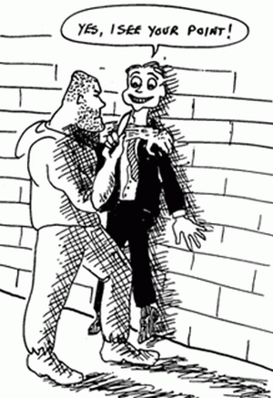
Red herring: | irrelevant distractions | 